Project 7: Code Errors and the Butterfly Effect

Ryan Scott and Diego Guerra

Grand Canyon University

CST-305: Principles of Modeling and Simulation

Prof. Citro

**Part 1:**

We needed to write a program that ran the following equations and executed them perfectly using Python:

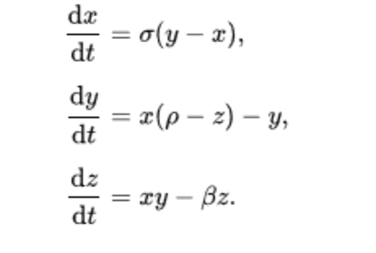

Users can enter a value for Rho in the Python program. Once the input is received, the 3D graph of the Lorenz system is displayed in an animated fashion. The program can be restarted and different values can be entered.

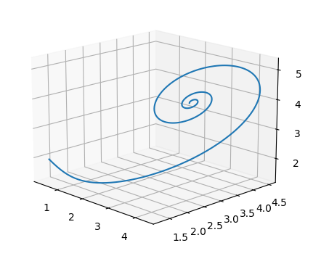

Animated result with Rho = 5

**Part 2:**

Q1:

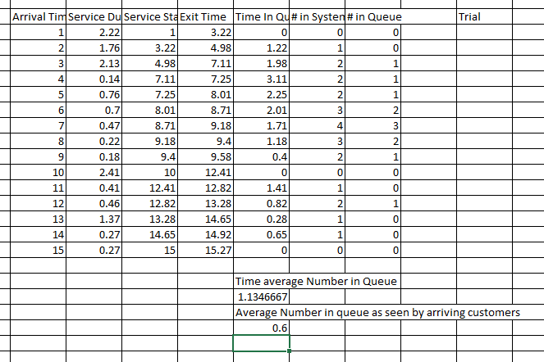

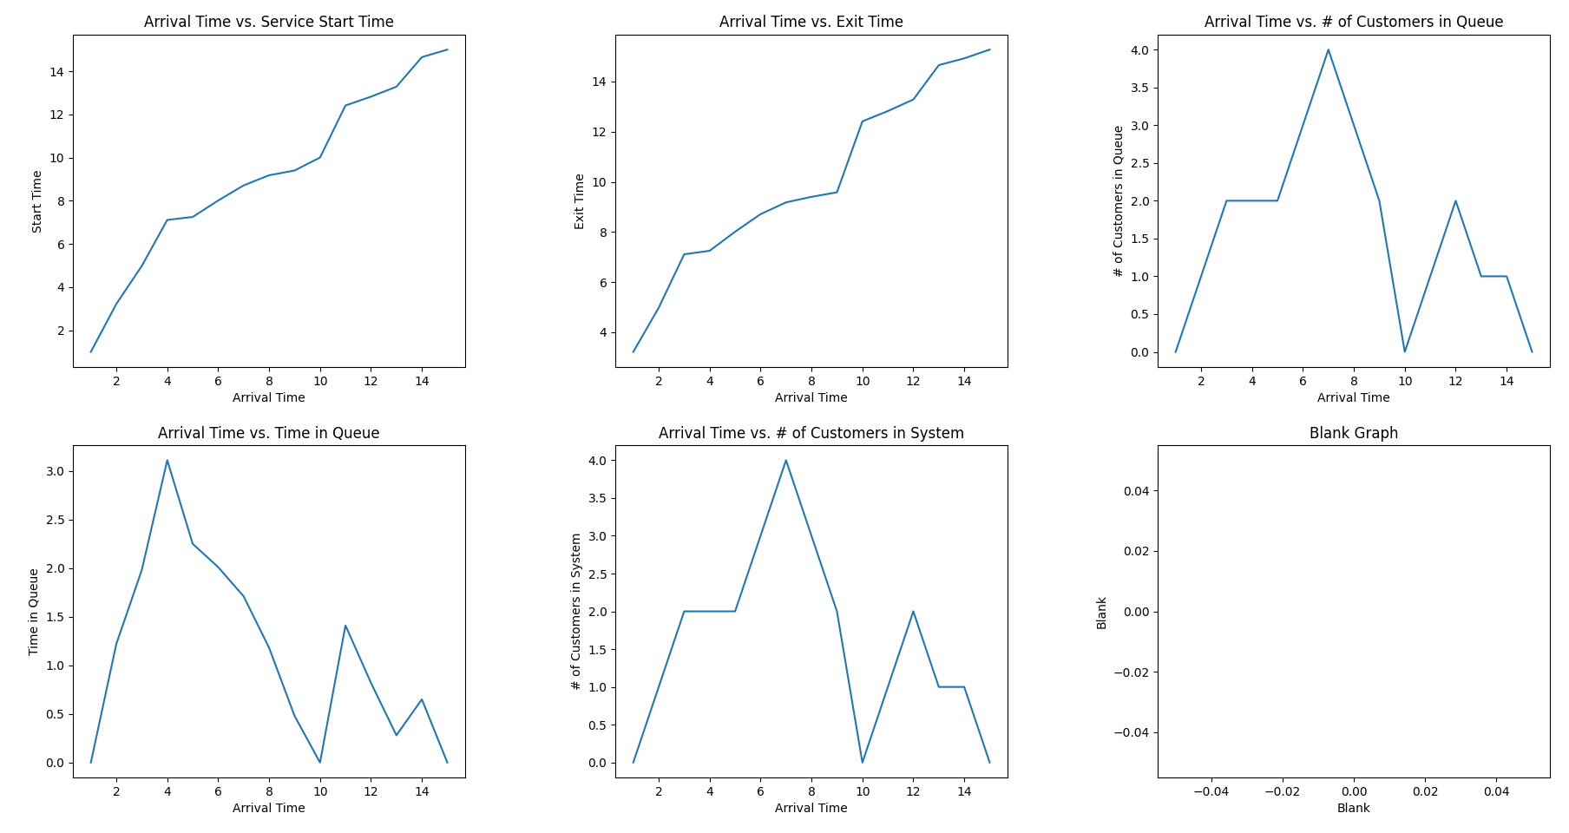

Using the arrival times and the service duration lists, one can obtain the service start and exit times, the length of the queue, the number of customers in the queue, and the number of customers in the system. These values are then calculated manually and put into an array and plotted using matplotlib in Python. It should be noted that despite a slight difference, the service start times and exit times follow a similar trend. In addition, the remaining three graphs also follow a similar pattern, with peaks when the arrival time falls between four and seven minutes.

Q2

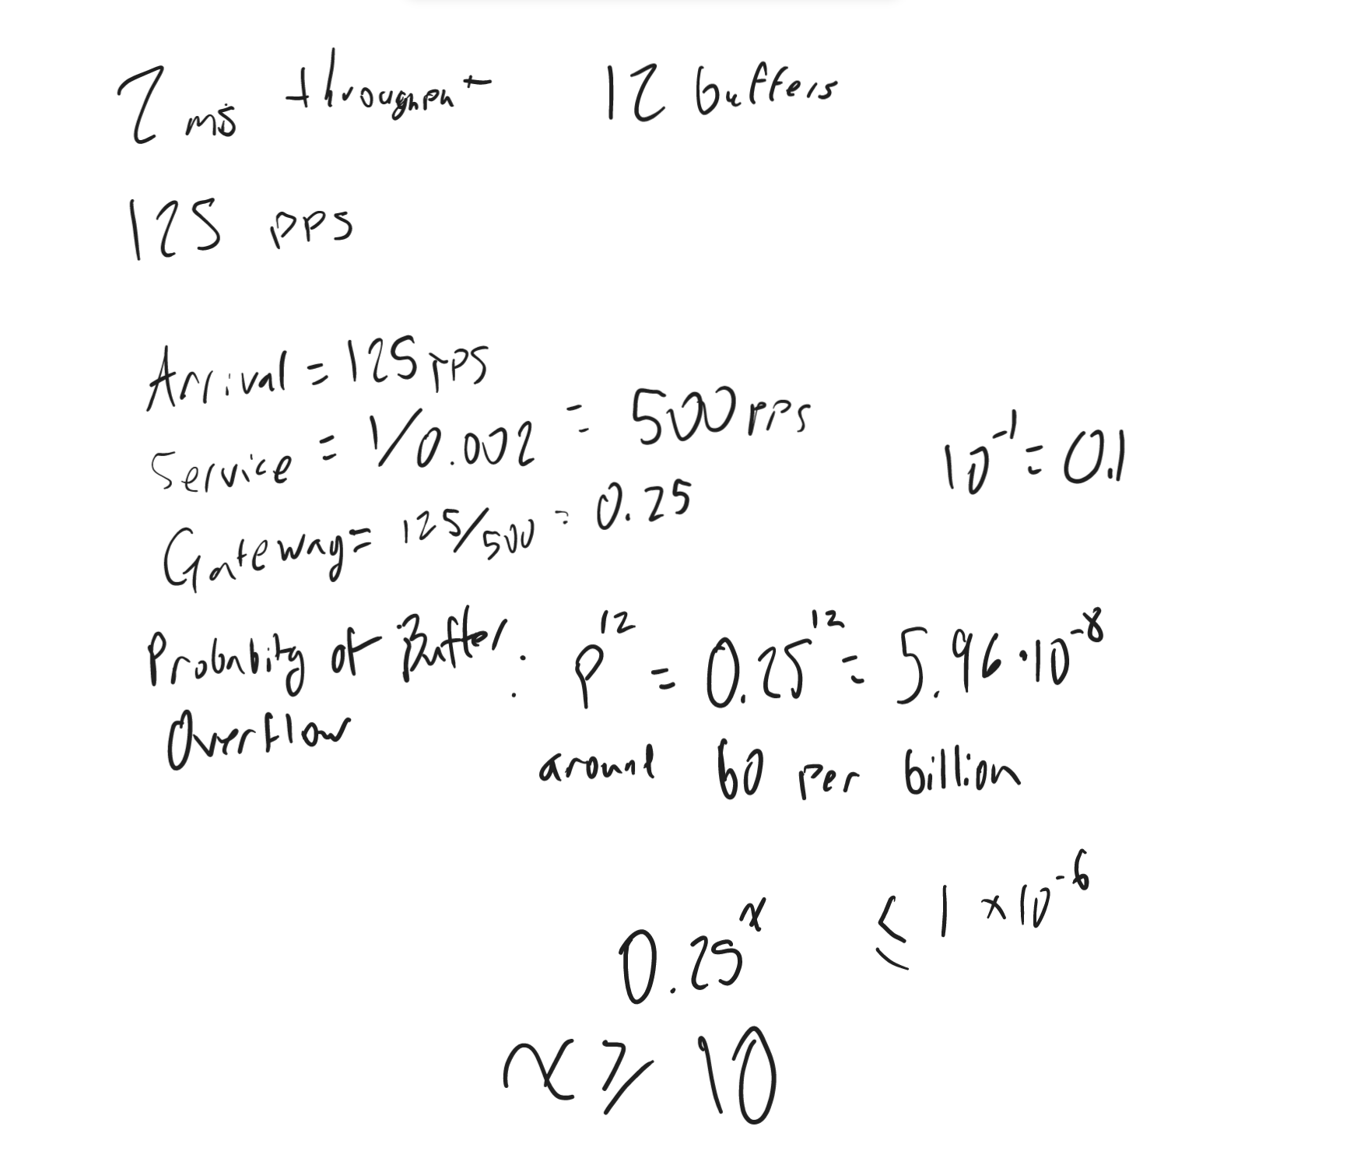

Q3

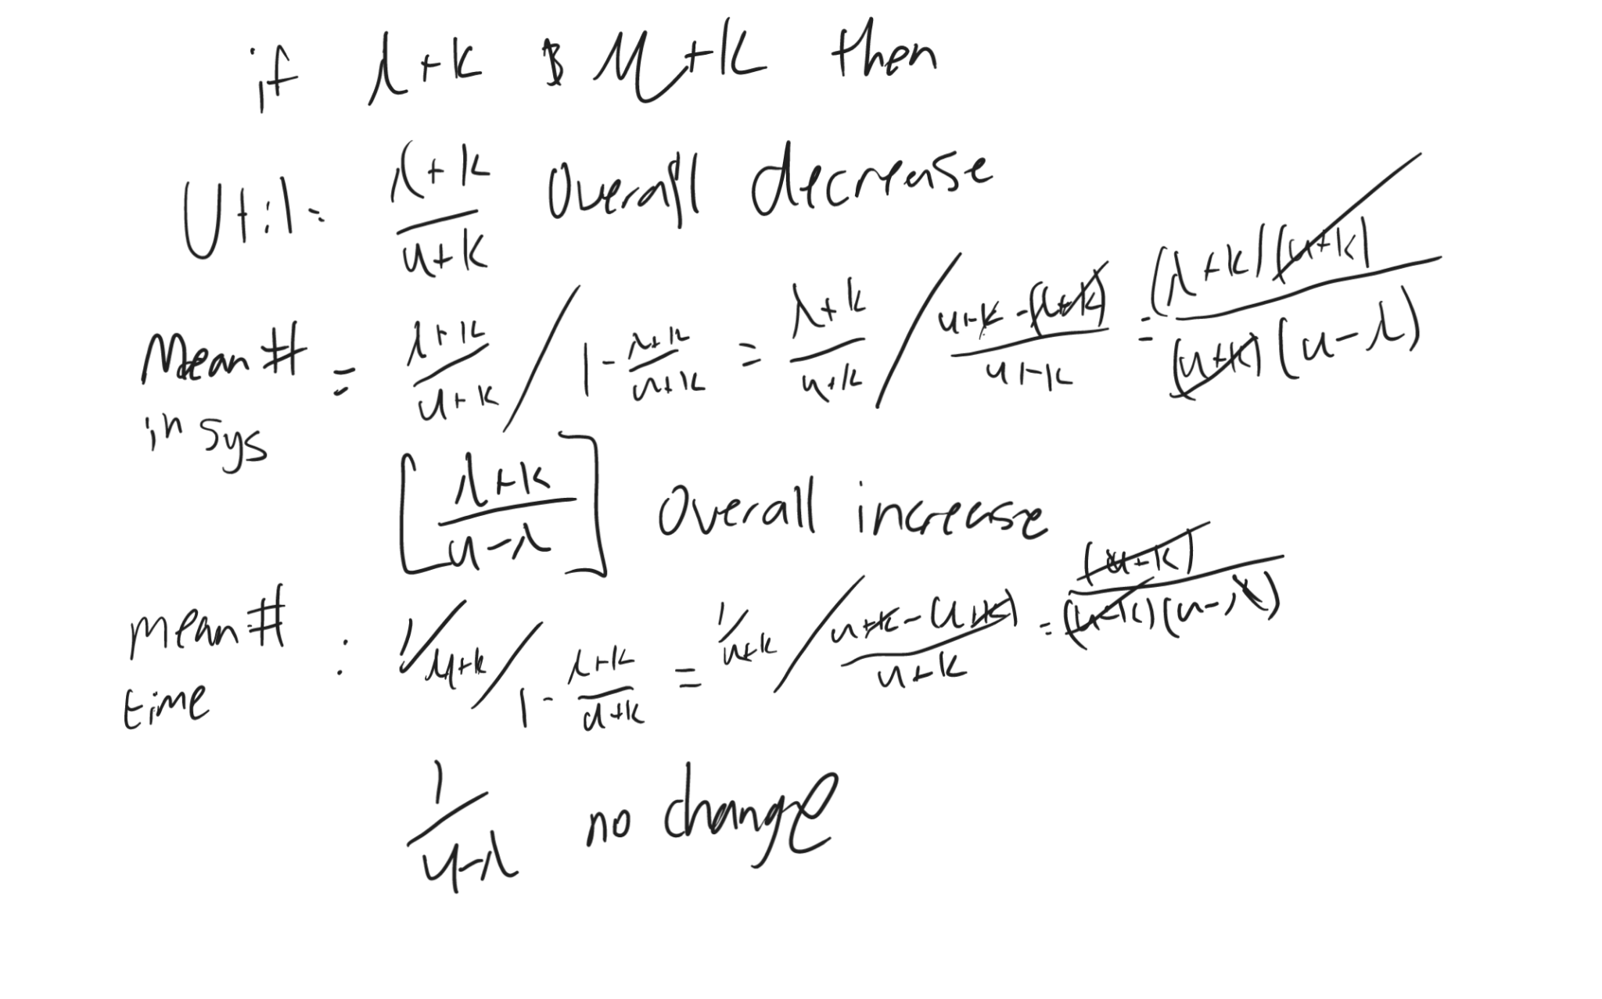



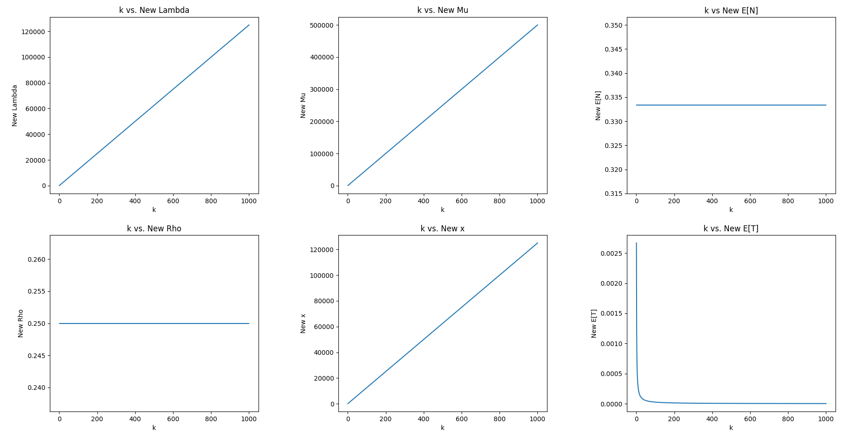

Q4

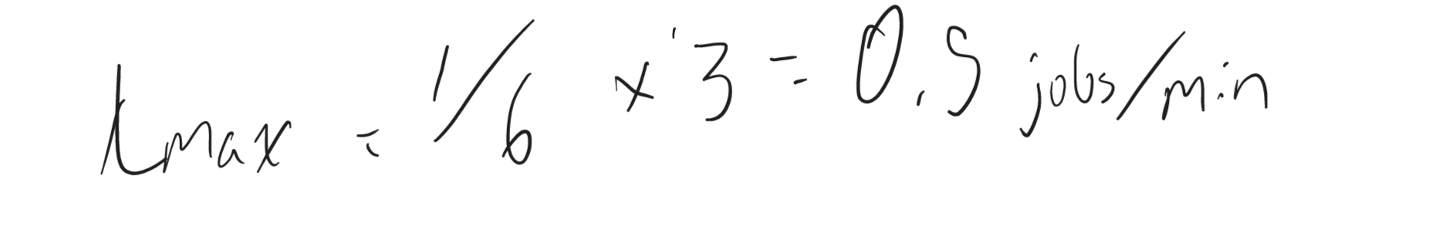

Q5

